Induction Ceremony
The Acorn Ceremony-Longhouse-New Members
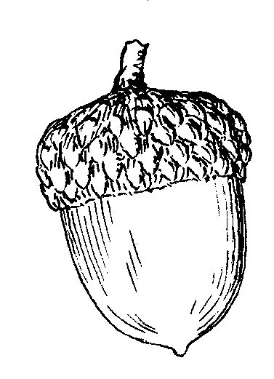
Overview: Induction ceremonies are typically held in the beginning moons of the program year and are primarily to honor new membership but it is also good to have all members reaffirm their pledge to the program and each other as well. This ceremony is generally written to be used in a group setting. The Acorn in this setting is meant to symbolize that as the acorn seed grows into a mighty oak tree, so too will the bond of love between father and child through Native Sons & Daughters Programs. All new father and children have been instructed in advance to bring an acorn to the ceremony. All fathers and children are expected to wear the Native Sons & Daughters headband to the ceremony. This should be announced and encouraged in advance.

Participants:
- Chief: Ceremonial Leader
- Medicine Man (or Assistant Chief): Co-leader of ceremony
- Sachem (or Great Elder)
- Fire starter Chief with fire lighting method prepared.

Relevant Ceremonial Pieces: (Customize to each) You may wish to incorporate this ceremony with other ceremonial components to form your full ceremony. The following are basic suggestions. Your creativity is your limit.
- Parade to Ceremonial Location
- Officer Inductions
- Special Awards
- Ceremonial Closing

INVOCATION
Medicine Man | O Creator, Great Spirit, whose voice we hear in the wind, and Whose breath gives life to all the world, hear us. Among your many children are we. We are small and we are weak. Your strength and wisdom we need. Make us walk in Beauty. Make our hands respect the things You have made. Make our eyes forever behold the majesty of the world around us and our ears sharp to hear your voice. Make us wise that we may know the many things You have hidden in every leaf and every rock. We seek strength, not to be stronger than our brothers and sisters, but to fight to be true to ourselves and our communities.
Chief | (Gives the Longhouse Salutation)
FIRE LIGHTING
Sachem | In times of old, the Fire was always at the center of the family. It provided warmth and safety; meals were prepared by its heat; but most of all, it gave comfort by the light of its welcoming glow to all those gathered around it. We, of the Longhouse Council are honored to share this fire with you, and hope that all may benefit from the friendship and wisdom of those gathered here tonight.
Fire Chief | (Lighting of the Fire)
 | Big Braves Sons & Daughters of the Mighty (Longhouse or Nation names), your Fall Longhouse Sacred Fire is prepared! (Longhouse Salutation)
INDUCTION CEREMONY
Chief | At this time, I ask each new Big Brave, Son and Daughter to please come forward and form a circle around the Sacred Fire.  (Allow time for this to happen)  Welcome to your first year in the Native Sons and Daughters  Tonight, each new Brave and their sons /daughters comes here seeking to be Pals Forever-Friends Always with each other. Members of the (Longhouse name), this is an eternal friendship between a Daughter and her Father. It is not fleeting like a rabbit dashing through the forest. It is not something to be bought with money or gifts of material things.  “Pals Forever-Friends Always” means that you will seek to become close, to understand one another better, to help one another at work and at play, and to learn side by side. You have embarked on a fantastic journey, fathers & your children that will reap many rewards!  I need the Big Braves, Sons & Daughters out there who know this to be true to give me a loud (Longhouse Salutation)!

Medicine Man | You were instructed to bring an acorn to the sacred fire tonight, just as this acorn will grow into a Mighty Oak, so will the bond of love between you and your daughter, with the Great Spirit’s help. All the Braves and Princesses that wish the bonds of love to be strengthened, hold your acorn high in the air (wait for them to do this) …the Great Spirit is pleased. You may put down your arms.
Sachem | BIG BRAVES! A character trait that can be an obstacle in strengthening this bond is selfishness. You must find the time to spend with your daughter. The fact that you are here, in this program, is a testament to your desire to do just that. Quality time is a myth…you must spend ample quantity time! You have only 18 summers to make a difference…make them count. Sacrifice the trait of selfishness and replace it with thoughtfulness.  Now Big Braves Approach the sacred fire and make that sacrifice. DADS ONLY, THROW YOUR ACORN INTO THE Sacred FIRE, then please step back with your child.
Sachem | SONS & DAUGHTERS! You’ve just seen your Big Brave father sacrifice selfishness for thoughtfulness. This means he is committed to strengthening the bond of love between you two. This does not mean that he will always be able to spend all the time with you that you want him to. Sometimes he won’t be able to…but know that he wants to. You must not be impatient. You must sacrifice impatience and replace it with thoughtfulness.  Son & Daughters, approach the sacred fire, make that Sacrifice by throwing your acorn into the sacred fire. Please step back with your father.
Chief | New Braves. Sons & Daughters, your sacrifice pleases the Great Spirit. Now, you must promise to each other to stay true to your sacrifice. Big Braves please face your child and get down on one knee… Place your right hand on their left shoulder. Son & Daughters, put your right hand on your father’s left shoulder… Now join left hands together…This position has great power. The hand clasp is a symbol of the closeness between a father and his child. Now look into each other’s eyes and repeat the Native Sons & Daughters pledge after me…  We, Father and Daughter, through friendly service to each other, to our family, to our Tribe, and to our community, seek a world, pleasing to the eye of The Great Spirit.  (Longhouse Salutation)
Medicine Man | As your Longhouse Medicine Man, I ask the Great Spirit to bless these Braves, Sons & Daughters, and to keep them safe and to guide them through this program and their lives together.
Chief | New Braves, Sons & Daughters, on behalf of the (Longhouse Name) Longhouse, I officially welcome you into the Native Sons & Daughters Program.  (Longhouse Salutation)  Remember what you have pledged here tonight. You may now return to your tribes.
 | Closing Ceremony as desired
Contributed by: The Timucuan Longhouse, Jacksonville, FL

